Pre-Kindergarten School Supplies
- Crayola Crayons ( 8 count; Jumbo) 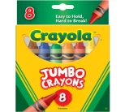
- Crayola Twistable Crayons (8 Count)
- Crayola Twistable Colored Pencils (12 count) 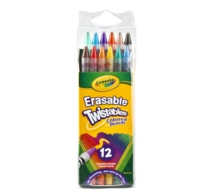
- One Washable Watercolor Palette (8 count) 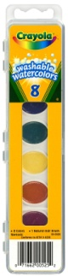
- Crayola Washable Markers (10 Count) 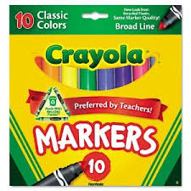
- Index Cards (100 Count;)
- One small bottle of elmer’s liquid glue.
- Pencil pouch (labeled with name). 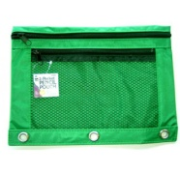
- Expo Dry Erase Writing Board (Lined on one side, Blank on the other side) 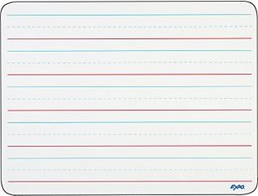
- Fat Expo Dry Erase Markers (low odor; assorted colors; 4 count) 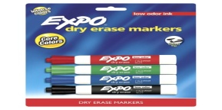
- One box of Gallon sized Ziploc bags
- Two boxes of small garbage bags
- Standard sized Backpack (labeled with name)
- Four large boxes of tissues
- Two large Clorox wipes
- Two large hand Sanitizer Wipes 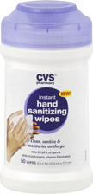
- Two 240 count of baby wipes.
- Four rolls of paper towels
- One extra set of labeled clothing (including socks and underwear)
- Folding Rest Mat 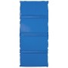(Include a blanket & fitted sheet.)
- 1 pack of white printing paper
- 2 Bottles of Lysol Disinfecting Spray
- Painting smock or old oversized t-shirt for painting (labeled with name)
- Poly portfolio 2-pocket folder 

